Help Afghan Refugees in Southern California and Elsewhere
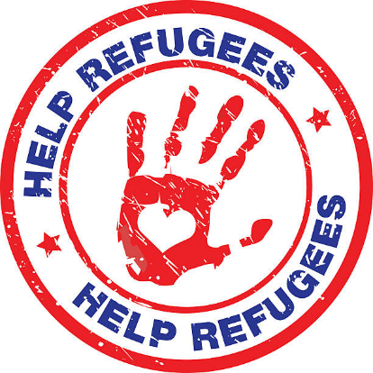
Looking for a way to support Afghan refugees settling in our area and around the country? Check out these agencies, which are working directly with the resettlement process:
Catholic Charities Diocese of San Diego is accepting in-kind donations of home furnishings, personal hygiene products, and back-to-school items. They also are accepting monetary donations and volunteer applications for a variety of positions. Refugee Services - Catholic Charities Diocese of San Diego (ccdsd.org)
Jewish Family Services of San Diego is accepting monetary donations as well as volunteers to act as tutors, mentors, and other types of assistants. The organization has resettled 129 families since August. Help Afghan Refugees - JFSSD
Lutheran Immigration and Refugee Service is not currently resettling Afghan families in Southern California so are not accepting volunteer applications in our region. However, the organization is accepting monetary donations and provides ways you can advocate for the Afghan refugees with Congress. Check out this interview about LIRS’ work with Afghan Refugees as well as links for how to donate and advocate for them. LIRS on NPR: Afghan Refugees Leading the Resettlement Mission
Miry’s List (headquartered in Los Angeles) works with Afghan families resettling in California as well as Virginia and Washington State. Each family sponsored has a short description as well as wish list from Target. You select the item you wish to donate and Target sends the gift directly to the family. Wishlists — Miry's List (miryslist.org) (We’ll be working with Miry’s List in the spring on God’s Work. Our Hands. Weekend to write welcome letters to the refugee families!) They also accept monetary donations as well as donations of various items. See Volunteer — Miry's List (miryslist.org) for suggestions.
Survivors of Torture,Inc is helping a large group of Afghan refugees living malnly in the El Cajon area. To donate or see about volunteer opportunities, go to Donate to SURVIVORS | Survivors of Torture, International (notorture.org)

